LONDON SOUTH BANK UNIVERSITY

Department of Computer Science

MS-DOS Evaluation

Prepared By:

Student ID

**22-03-2024**

# Contents

**Abstract** II

Introduction III

1. Downloading Software’s IV
   1. What is virtualization?
   2. What is Hypervisor and its types.
   3. Virtual Box.
   4. Virtual Box Extension Pack.
2. Downloading Ubuntu. V
   1. What is OS?
   2. Types of OS.
   3. Ubuntu OS
   4. Ubuntu Pro Service’s
3. **Installing Virtual Box. VI**
   1. Installing its extension pack.
4. **Installing Ubuntu on Hypervisor. VII**
   1. Some key points to know while installing.
5. **Ubuntu Operating System. VIII**
   1. Updating and upgrading.
   2. What are build essential.
   3. Kernel memory usage.
   4. Built-in tools.
   5. Processes hierarchy.
   6. Applications.
6. **MS-DOS Operating System. IX**
   1. Introduction.
   2. Kernel Usage.
   3. Benchmarks.

## Conclusion. X

## Abstract.

### This document shows the basic use of Ubuntu and MS-DOS operating Systems. This demonstrates a good comparison between both operating systems. A good comparison includes both kernel usage, memory usage, processes alignment, dispatcher, scheduler and much more.

First half of this document demonstrates the concept of virtualization, its uses, draw backs, advantages and disadvantages over the previously used technology called as Dual Boot. Its global presence in the technological Industry as well as modern data centers.

Moreover, it also introduces us to the hypervisors and their usage in this era. It also helps us to understand the difference between hypervisors and how to use it. In addition, it describes us and tells when to use which hyper visor and to what extent.

Furthermore, it also helps us to install basic hyper visor (VirtualBox) developed and maintained by JAVA technologies. Clear’s our vision on how to install another operating system such as Ubuntu OS on a Windows machine using a hyper visor.

At all, it shows the basic usage of both tech giants Ubuntu and Microsoft Operating system (MS-DOS) and describes the difference between them by comparing many aspects such as

Memory distribution, CPU Core Alignment, GUI on both systems, basic terminal commands and much more.

**Introduction.**

### 2.0.1. Scope

### 2.0.2. Overview

### 2.0.3. Importance

### 2.0.1. Scope.

2.0.1.1. This covers the scope of different OS such as Ubuntu and MS-DOS and compares their different tools and resource management.

### 2.0.2. Overview.

2.0.2.1. In old ages, there were not many OS(s). Debian and MS-DOS and Batch OS was the first one to be introduced. This document compares two most important OS  
(S) from two different time zones. Ther are Ubuntu and MS-DOS.

### 2.0.3. Importance.

2.0.3.1. It is important to cover these type of topics as it helps modern youngsters to understand how much technology has evolved within a time span of a decade.

# Downloading Software’s

## What is Virtualization?

[Virtualization](https://www.ibm.com/topics/virtualization) is a process of running different/multiple operating system(s) on one device. Before virtualization dual boot was used by many customers and enterprises. Virtualization makes use of a software which is an operating system in itself. It runs on the windows operating system and enables that machine to run multiple other OS(s).

This is made possible by introducing new Intel chips e.g. Intel i7 8th gen 8870H processor.

This mode needs to be enabled in the computer BIOS in order for it work. It efficiently manages resources of host operating system to be distributed to other slave machines and can be managed by one single software known as hypervisor.

It makes possible of many techniques such as resource management, easier management,

Minimal downtime.

## What is Hypervisor and its types.

[Hypervisor](https://www.vmware.com/topics/glossary/content/hypervisor.html) is a software that is used for making the concept of virtualization possible. These software’s are developed by companies like VM Ware, Oracle and Hyper-V and are used almost everywhere in the world either it is a home office setup or a cloud based system.

Hypervisor enables an organization to be more resource efficient and manages its flexibility, speed in various conditions. All data centers are using the ideas of hyper visor to create pool of storage and maintain them by one single software knows as hyper visor. It also helps an organization to be more backup free.

If in case there is some sort of server failure, this technology doesn’t shutdown the whole facility instead only the machine that is causing problem.

* + 1. Types of Hyper Visor’s.

1. Hypervisor 1
2. Hypervisor 2

### **Hypervisor** 1.

* + - * 1. This type of hyper visor is directly installed on the bare metal system. This is the most used type of hyper visor in the industry and is used in every data center all around the world. Most common types of this type of hyper visor is VM Ware vSphere. This is a paid software that enables an organization to make its infrastructure more scalable and flexible in almost any kind of environment.

### **Hypervisor** 2.

* + - * 1. This type of hypervisor is used by students or small offices. Most common examples are VM Ware Workstation, Oracle VirtualBox. For inspecting, we will be using Virtual Box. It is totally free and can be downloaded by anyone.

## Virtual Box.

## This is the type 1 hypervisor. It can be downloaded from this [link](https://www.virtualbox.org/wiki/Downloads). Moreover, this is managed by JAVA Oracle databases. It’s a light weight software and can be execute on lower end pc’s.

## Moreover, this can be used to virtualize any kind of operating system such as Windows, Linux, Debian, Solaris. For this assignment we will be using Ubuntu on Windows Operating System.

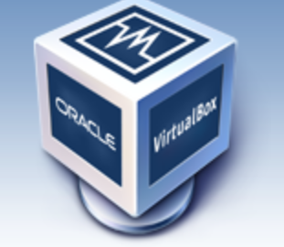

## Virtual Box Extension Pack.

## This is another piece of software that is provided alongside Virtual Box. The main purpose of this software is to smoothens the connection between host and slave operating system such as capturing Key board events, Mouse movement.

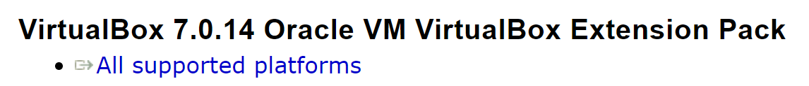

## Downloading Ubuntu.

## .1 Ubuntu is a Debian based kernel operating system. It is most commonly used in almost all over the world by companies to manage work and users for their employee’s.

## What is OS?

### OS stands for an operating system. The main purpose of an operating system is to manage the kernel resources as efficient as it could be by executing different scheduled processes that are stored in RAM (Random Access Memory).

### There are many types of Operating system(s) such as Windows 11, Windows XP, Kali Linux, Ubuntu OS, iOS, Android.

## Types of OS.

* + - 1. There are many types of operating systems. These includes Windows, Linux, Debian, RedHat, Batch, Solaris, iOS, Android.

In today’s era, most common used operating systems are Windows, Ubuntu, Android, iOS.

Windows:

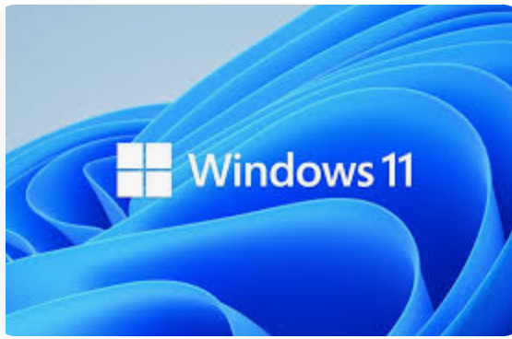

Debian:



Ubuntu:

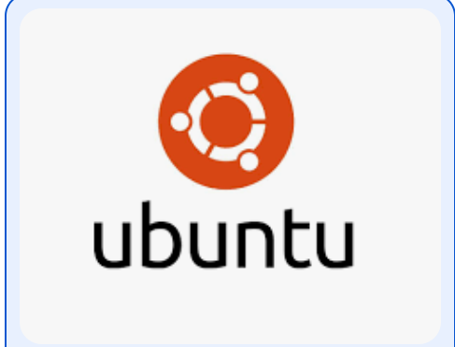

## Ubuntu OS.

### Ubuntu OS is developed on kernel that is based on Debian’s Kernel. It is most used by the industry to manage employees and administrators.

### This Operating system includes various system applications such as terminal, transformer, files, permissions.

### The most basic use of this operating system is that it doesn’t allow an application to run until it has executable permissions. These permissions are managed by the user itself unlike Windows which manages by itself.

### To change the permission of a file, [chmod](https://en.wikipedia.org/wiki/Chmod) command is used.

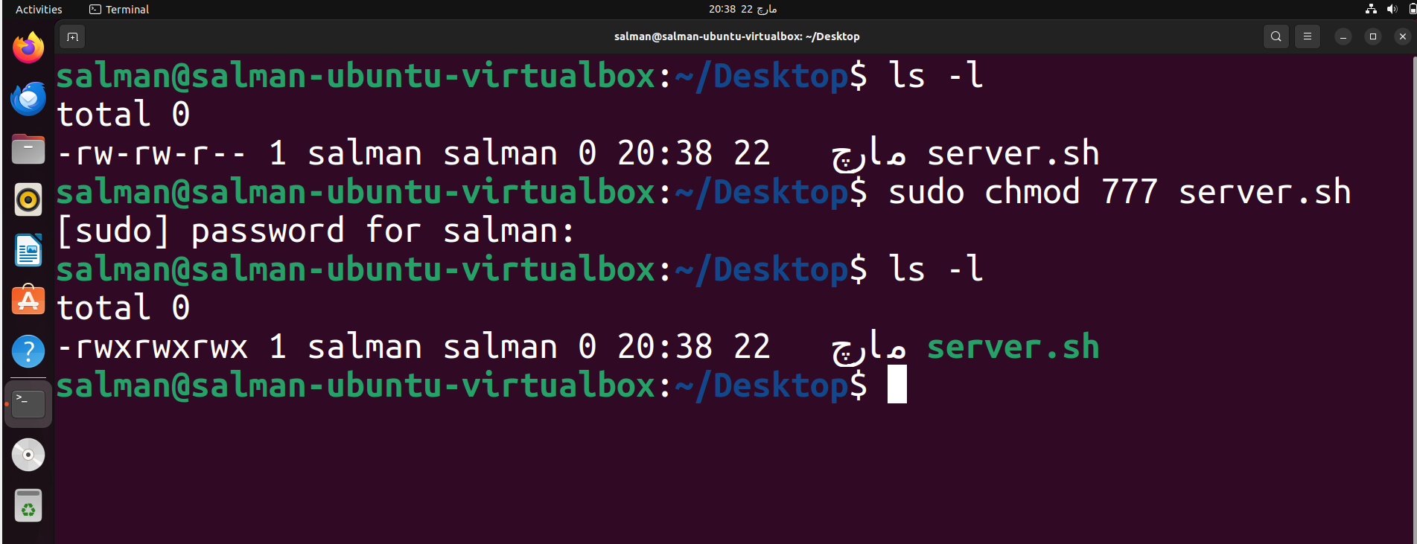

## Ubuntu Pro Service(s).

### [Ubuntu Pro](https://ubuntu.com/pro) is a piece of software that is paid. It is asked by the used after the fresh install of OS whether he/she wants to purchase it or not.

### Its professional features includes instant security updates and patches. Cloud based backups and immediate customer support. This is same as Windows Pro in a Windows based environment.

## Installing Virtual Box.

## First download virtual box from the following [link](https://www.virtualbox.org/wiki/Downloads).

1. Then double click on the executable file if you are working on a windows operating system.

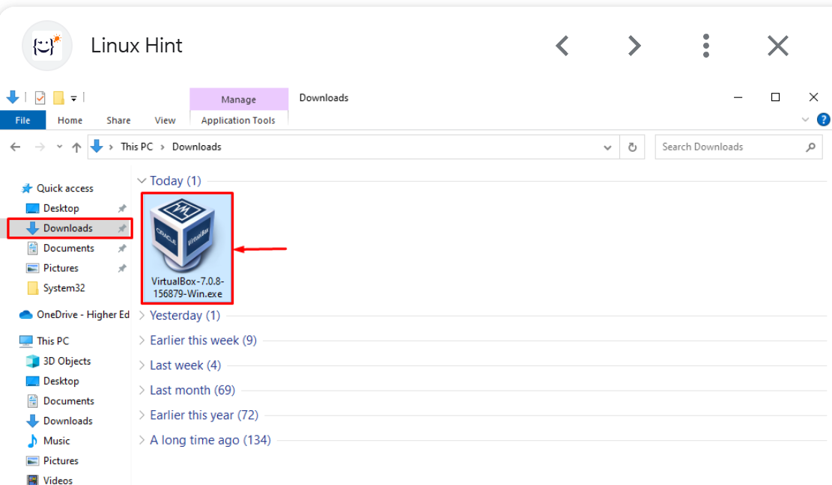

1. After that, click yes to grant permission to run the file.
2. Continue clicking on next and adjust the settings as per required.
3. At last, after the executing is complete, Virtual Box will be installed on your system.
4. Please make sure to reboot, for a clean start at first time.

## 3.1. Installing Its Extension Pack.

### 3.1.1. To install its extension pack, download it from [here](https://www.virtualbox.org/wiki/Downloads).

3.1.1.1. After downloading, open virtual box application and go to File > Tools > Extension Pack Manager.

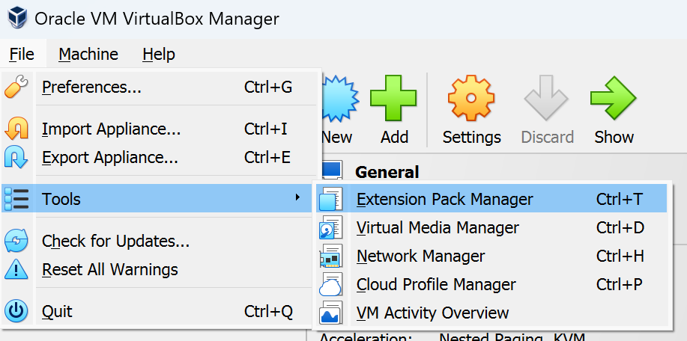

3.1.1.2. Click on it, then it will take you to the following window.

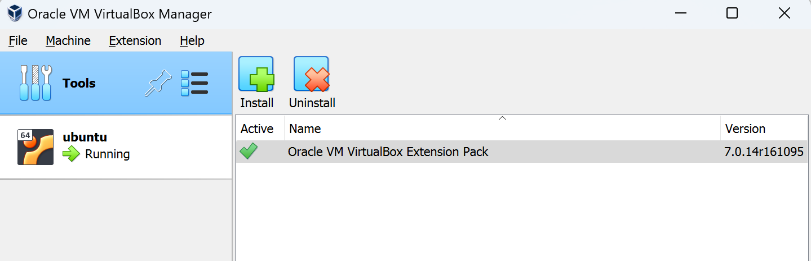

3.1.1.3. Click on Install and browse the location where you have downloaded your extension manager from internet.

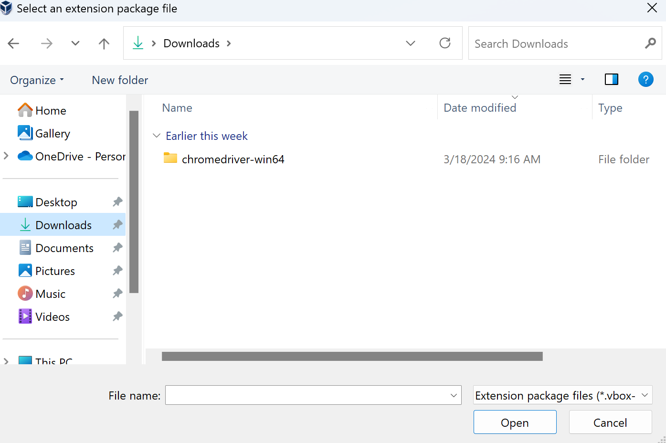

3.1.1.4. After clicking, it will install that extension manager for you.

3.1.1.5. It’s a good practice to reboot system afterwards.

## Installing Ubuntu on Hypervisor.

## Open Virtual Box and click on Machine > New.

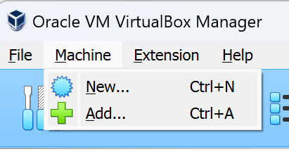

## Then, input a name for your machine.



## Then, select the ISO image that you downloaded earlier from Ubuntu Official website.



## After selecting the path to your .iso file, checkbox “Skip Unattended Installation”.



## Click on next, and choose RAM and number of processor for your OS.

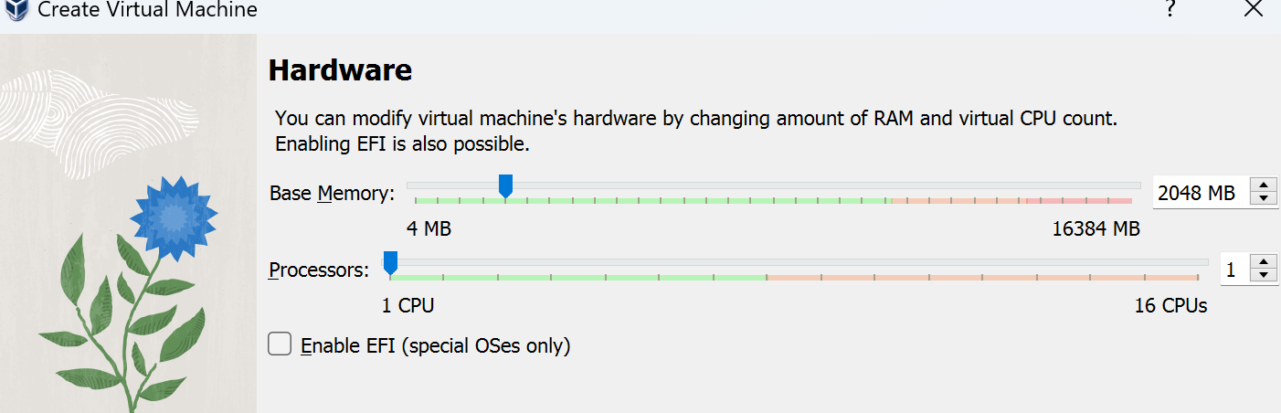

## Choose a size of your virtual hard disk.

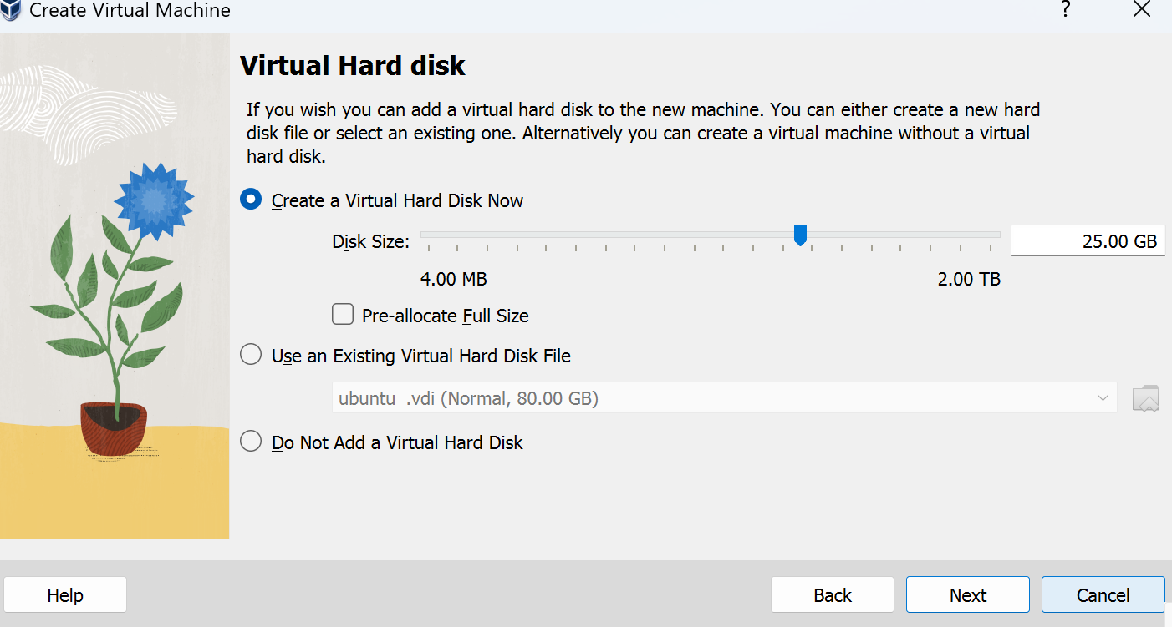

## Then click next and finish. If you see the following page, then you have successfully made a new Ubuntu OS virtual machine.

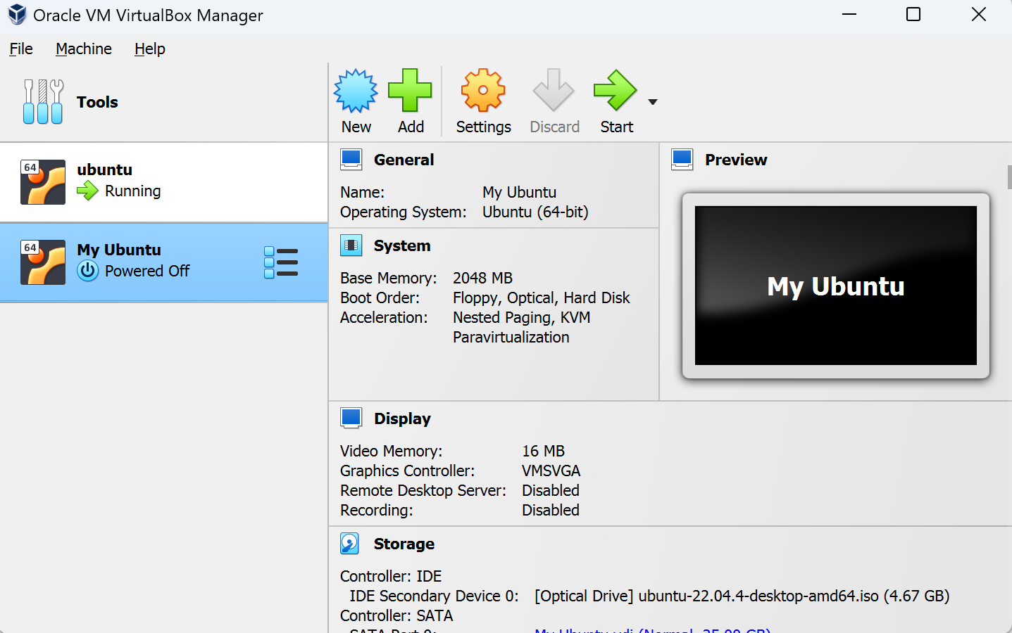

## Now you need to double click on machine named as “My Ubuntu” and it will start to run in a virtual environment on your system. We need to install Ubuntu on it. For this purpose, click on “Try or Install Ubuntu”.

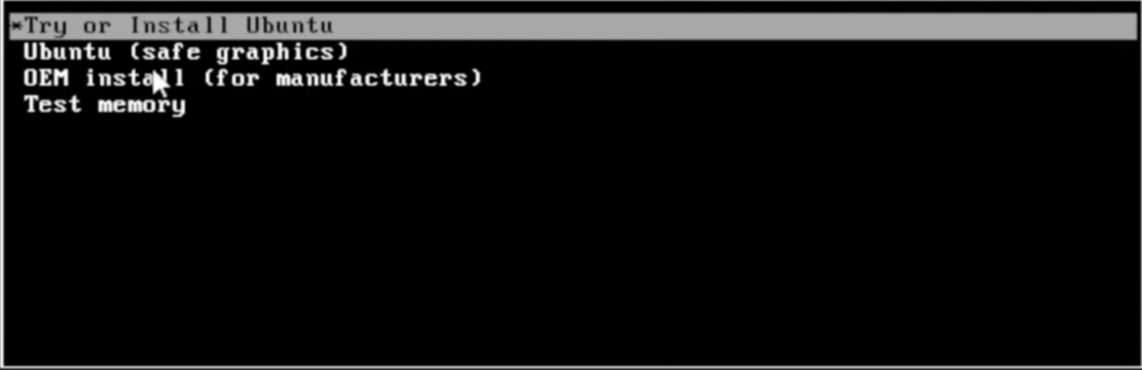

## Now click on Install Ubuntu.

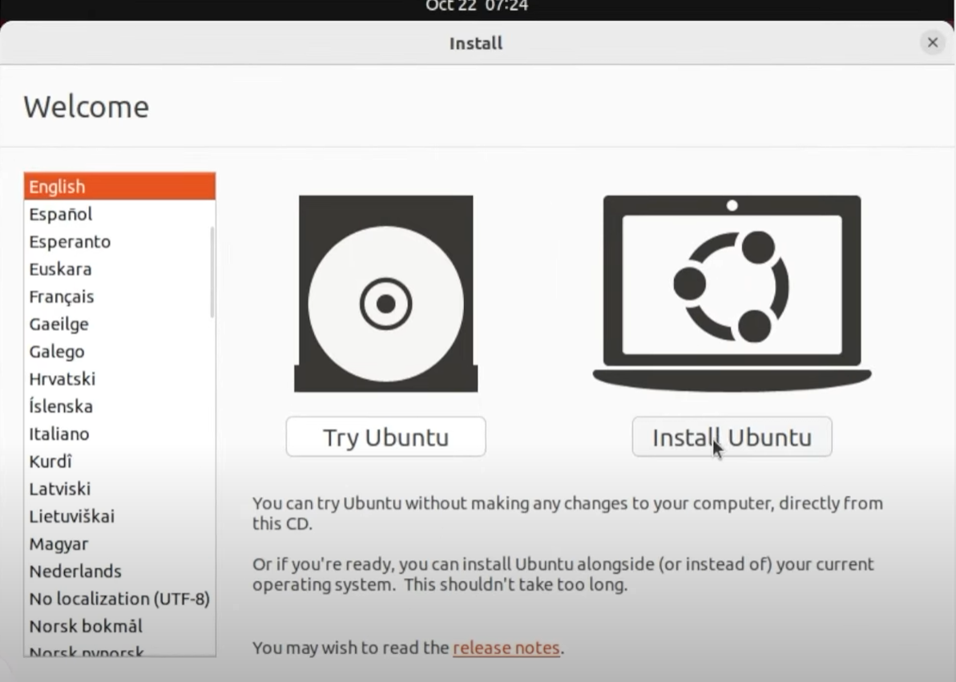

## Choose Keyboard Layout and click on continue button.

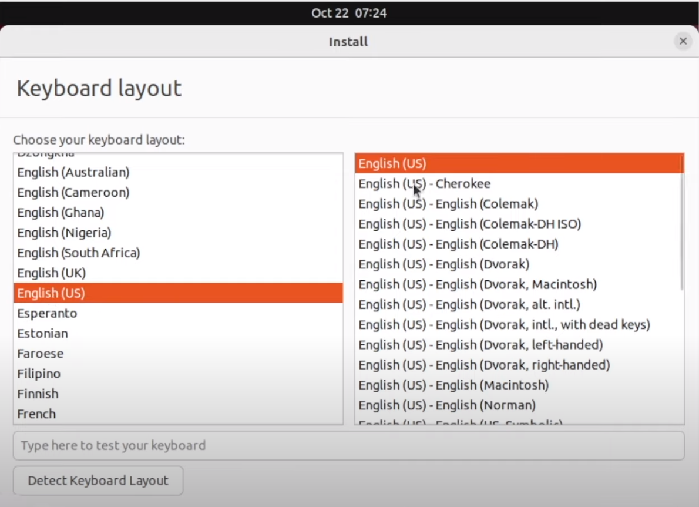

## Select the following settings.

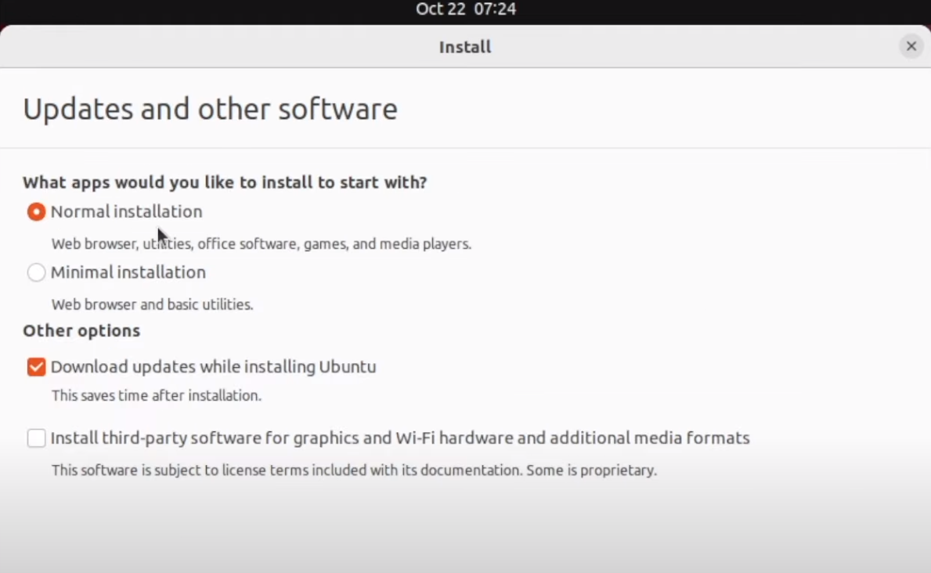

## Again, select following settings and click on continue.

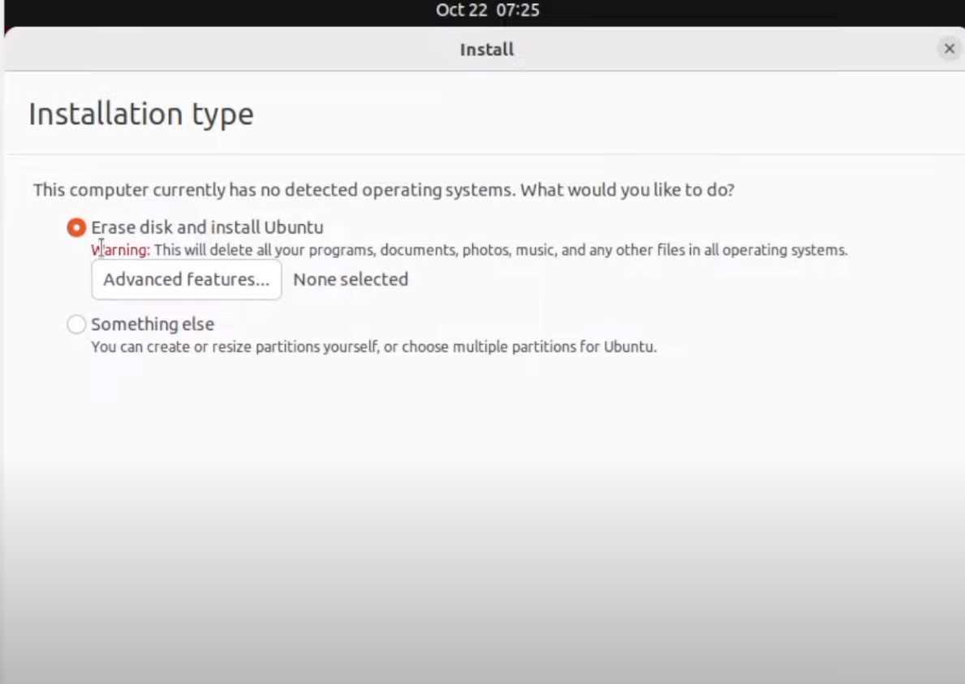

## Select your region.



## Write your name, password and computers name.

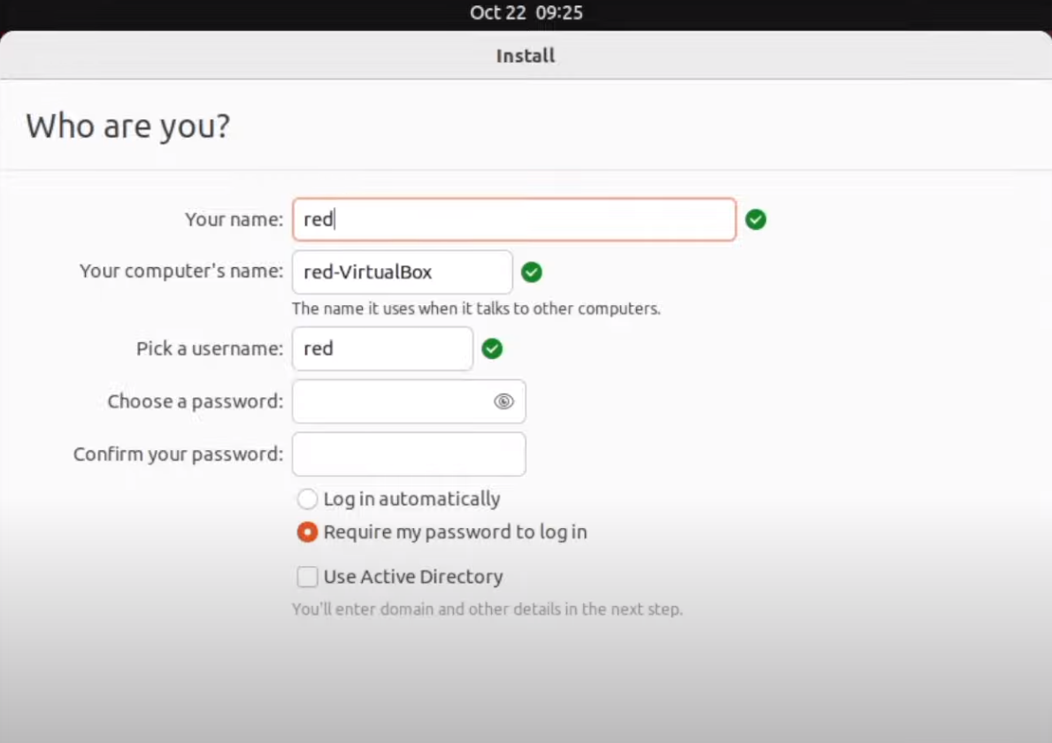

## It will start to install Ubuntu.

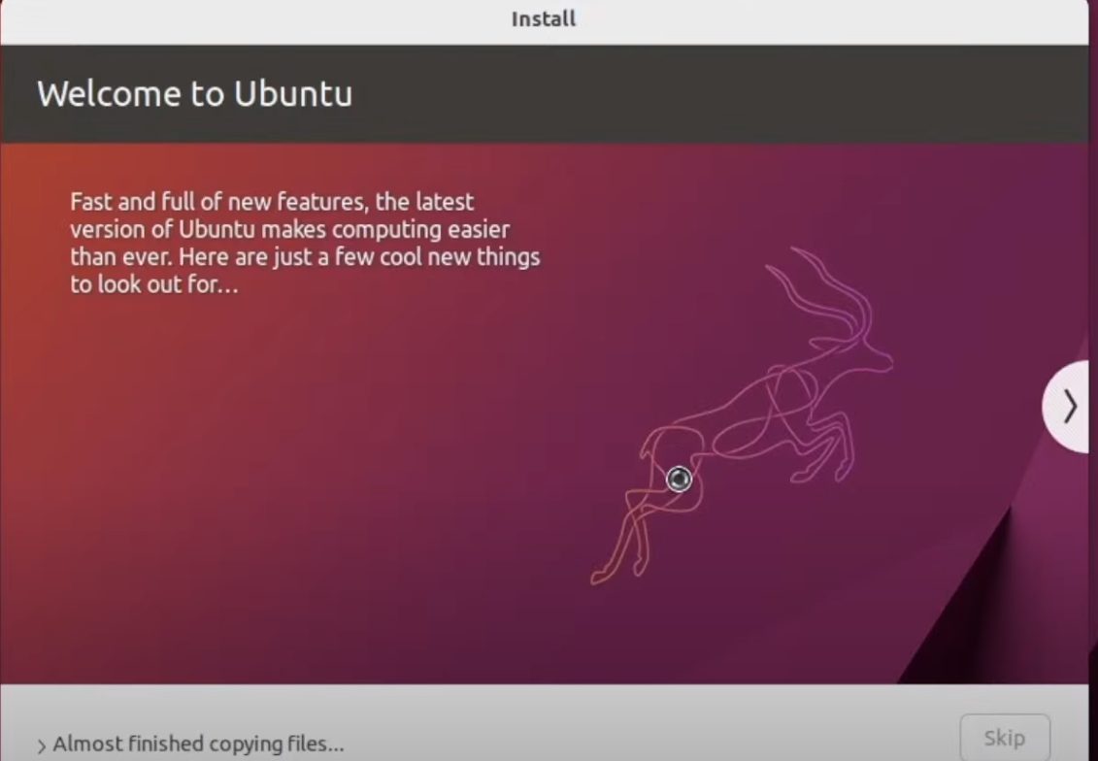

## Click on Restart now,

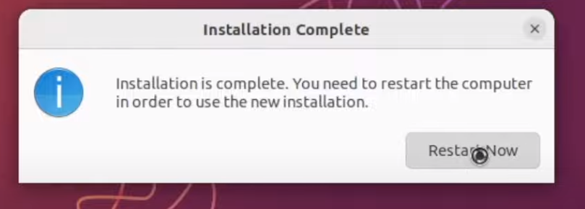

## It will restart and will as you about your login details.

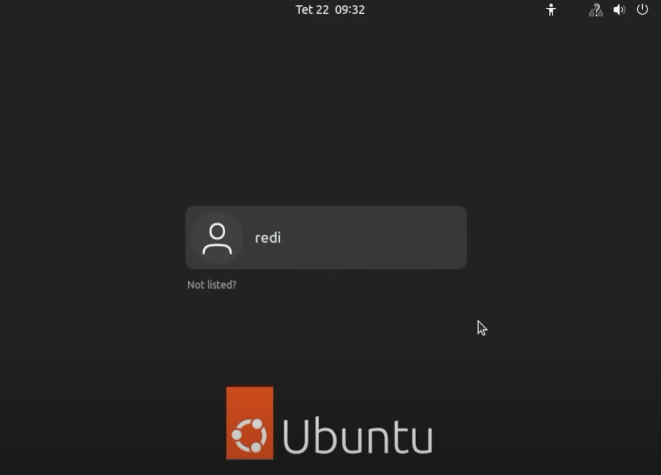

## Hurrah. You have successfully installed Ubuntu as a virtual machine on your computer.

# Updating and upgrading.

## It is very important to first update and upgrade your system after you install it for the first time.

## To do this, open a terminal “ctrl + alt + T” and write this command as follows,

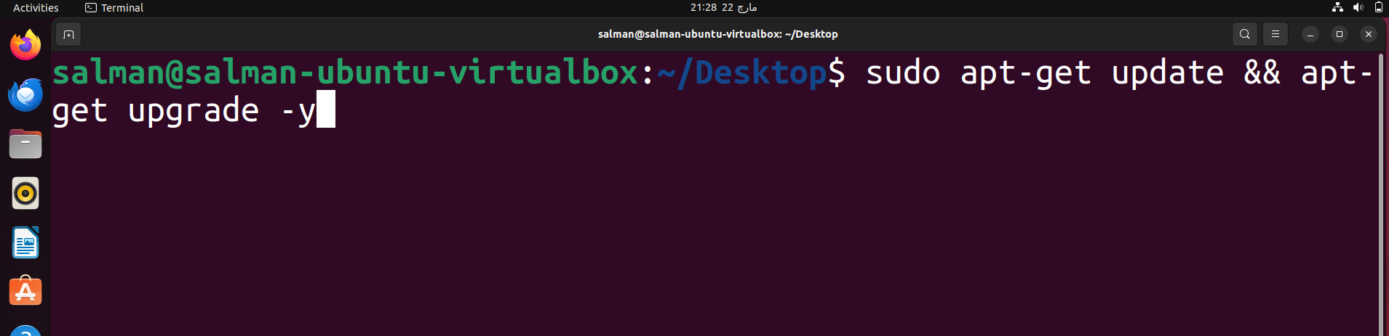

## What are build essentials. This is a piece of a software which is used to compile many different binaries and make them able to run on your computer. These includes make, perl and many more.

## It is very important to update build essential as soon as you install Ubuntu on your system. To achieve it,

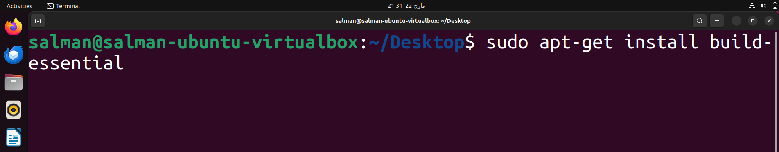

## Kernel Memory Usage.

### Ubuntu uses a Debian based kernel. In order to check how much memory is being used by the system at current time.

* + - * 1. There are several ways to check this, First, is to use System Monitor Application that is provided as System Application by the Ubuntu Operating System. To run it, just press windows button on your laptop/computer and search for System Monitor.

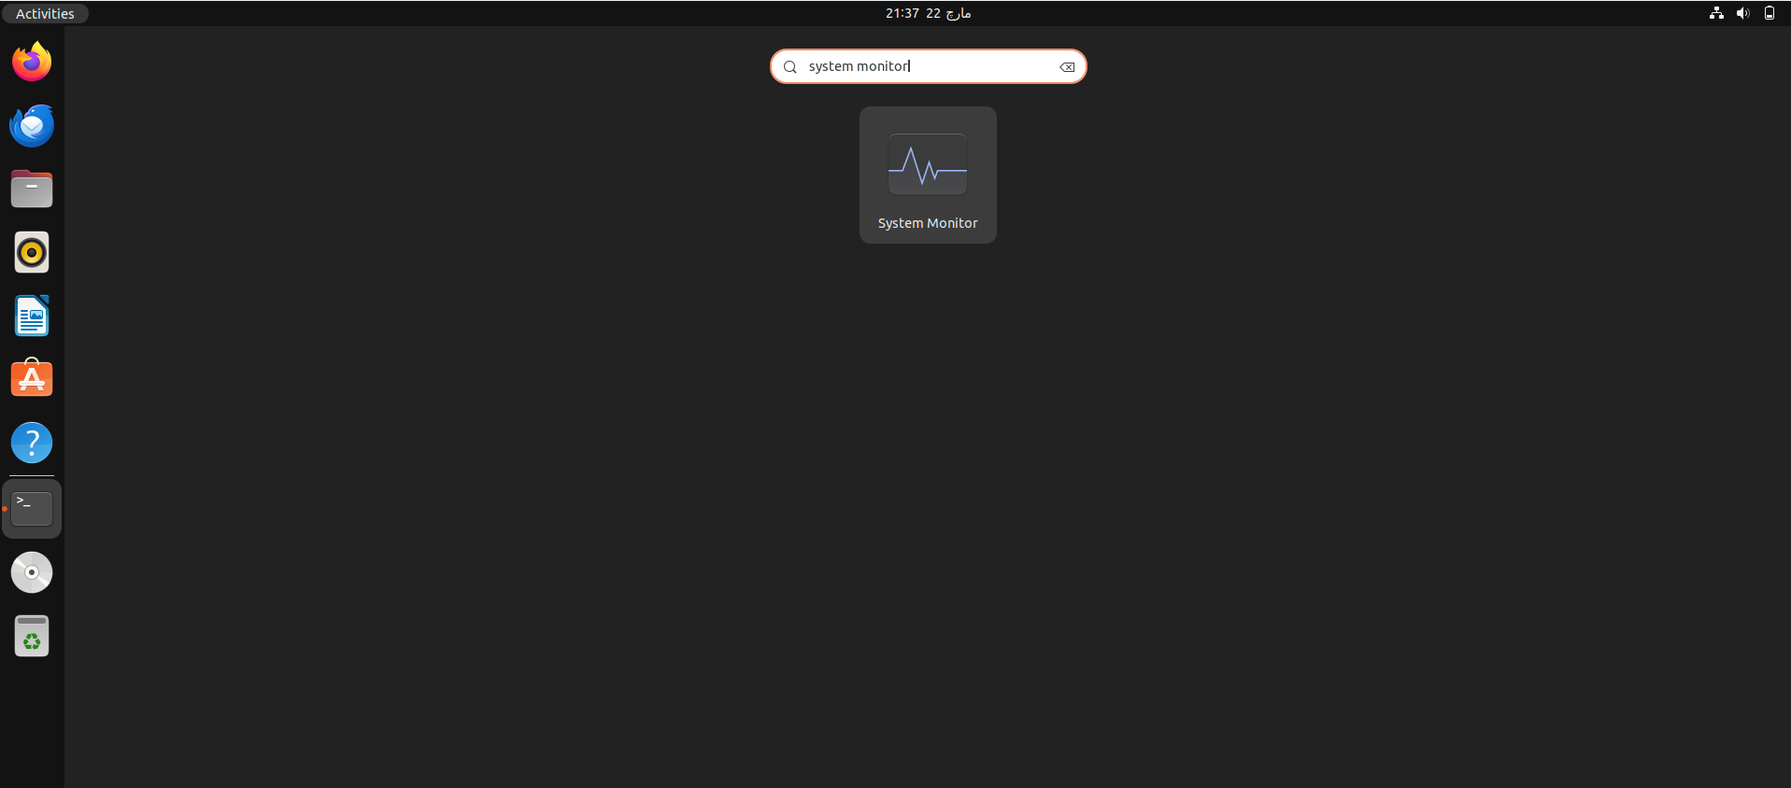

* + - * 1. Then press enter to run. You will see following output.

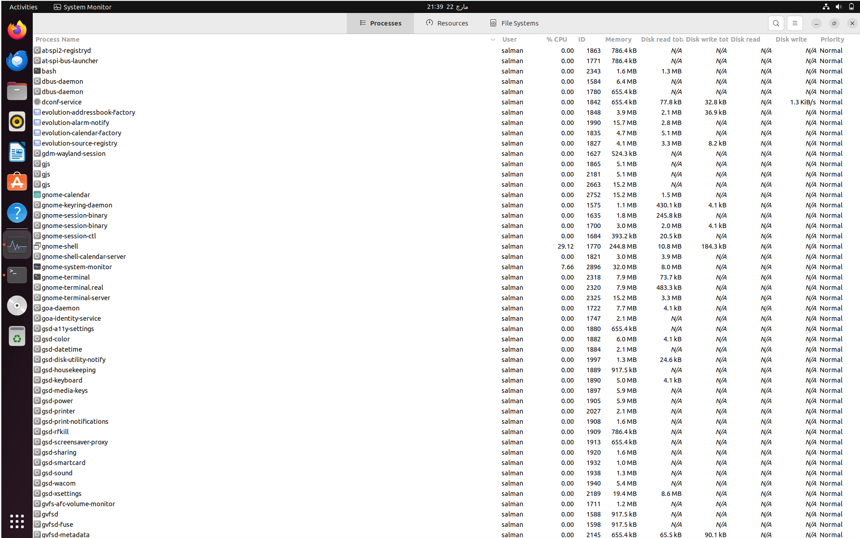

These are all the processes that are being executed by the kernel. In order to have a glimpse of your system RAM and CPU usage, select Resources tab from the top middle of your screen.

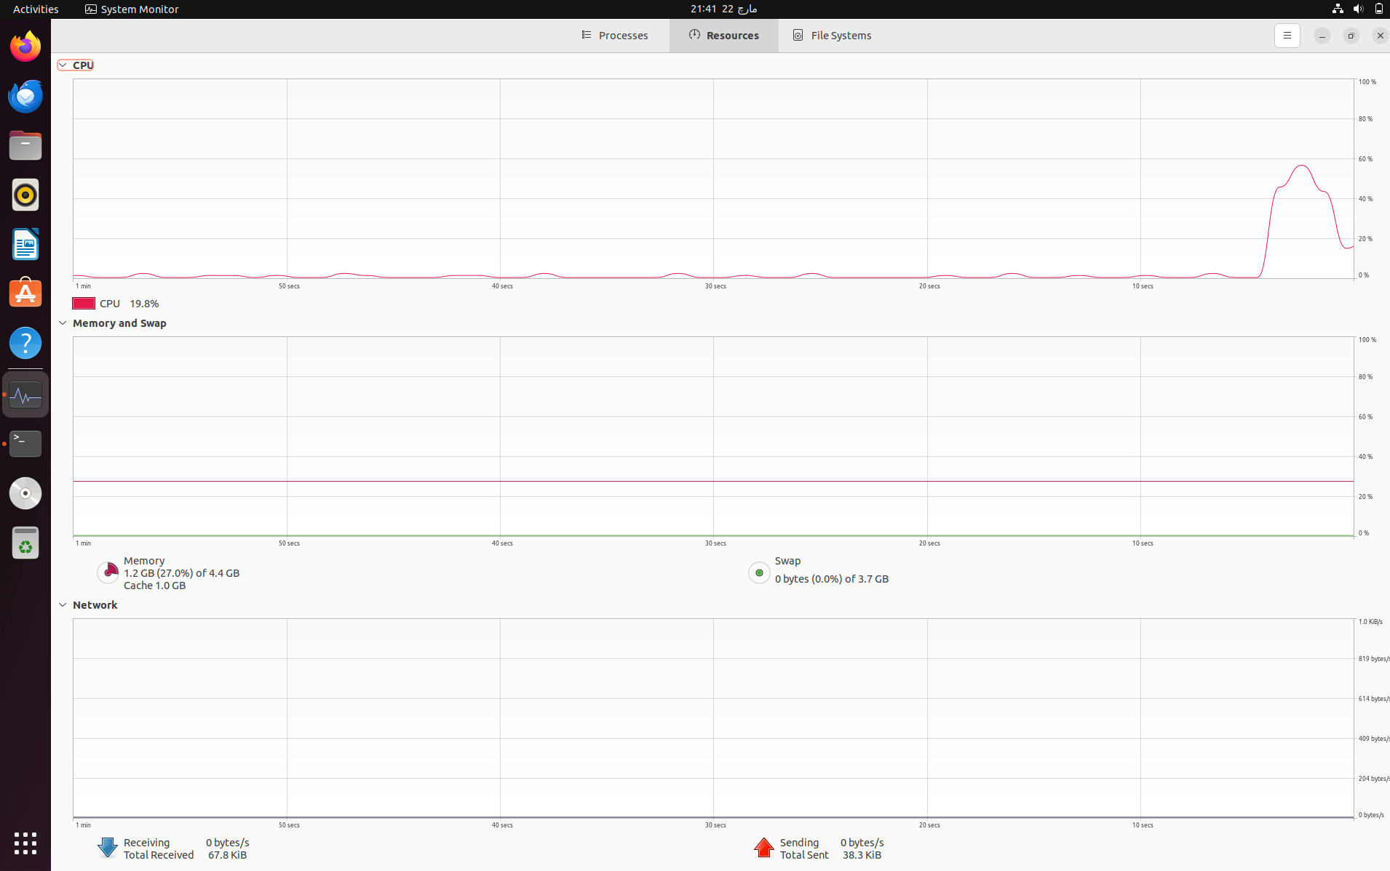

This will display how much memory and cpu in being used now and how much is remaining. As you can see in the image that, 20% of the CPU and 1% of the RAM is currently used by the system to meet its basic needs.

### Another way to check your system resources is by using a terminal. To open a terminal press “ctrl + alt + T” at once and it will open a terminal window on your screen. Then enter the command as shown in the image.

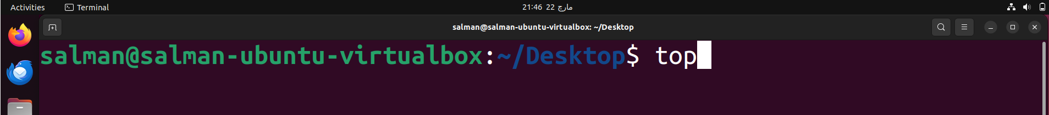

* + - * 1. Now press enter and you will see the following results,

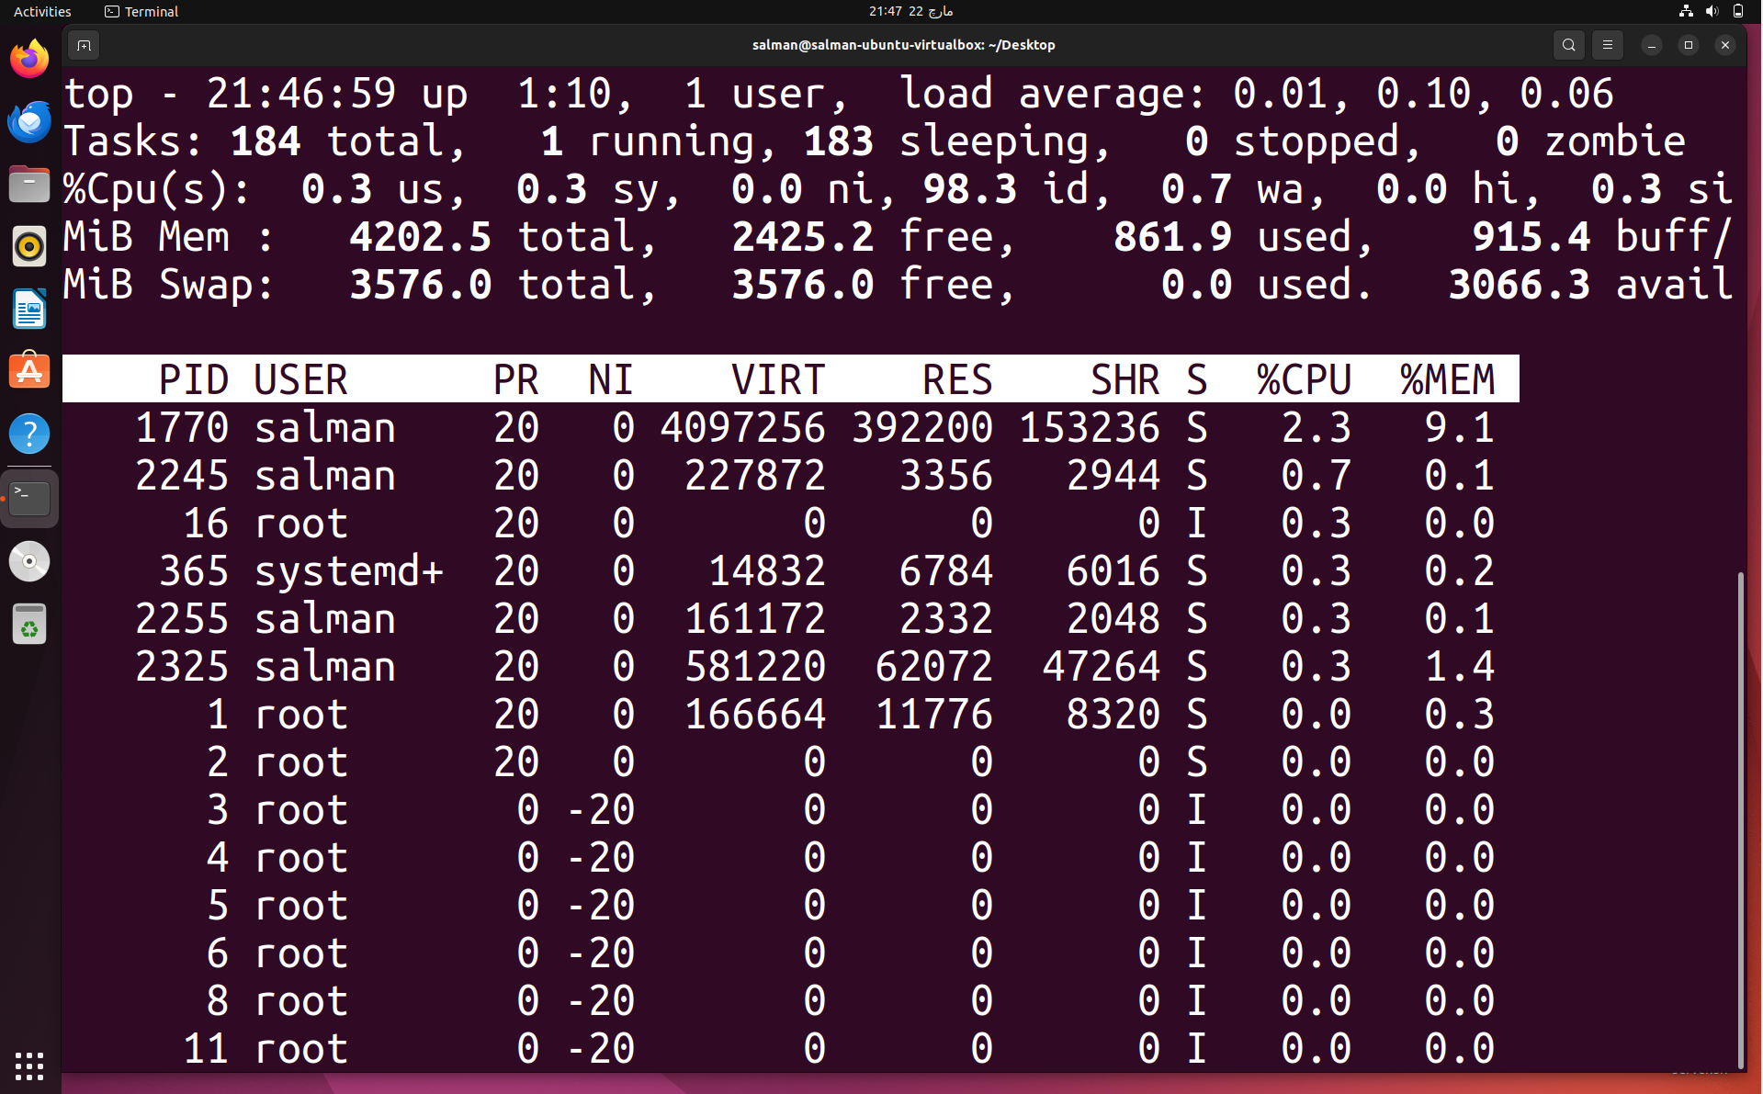

These are also the same processes that was shown by the system monitor application earlie.

* + - * 1. To exit just press “ctrl + c” and it will terminate the program.

## Built in Tools.

### Locate Utility.

* + - 1. Locate utility is included in the defaults applications of the Ubuntu System Applications. This helps to locate any file on the system. User can also provide a specific path to look for.
      2. Ubuntu Software.

This is the applications store for ubuntu. Users can download and update also uninstall existing or faulty applications from their systems.

## Process Hierarchy.

### For a long time, Linux systems have used init modules to handle all processes in a Linux computer. But with modern age this has been changed to “system-md” utility. This also becomes parent of a process in case it is a zombie process. System MD is the root of all processes at any time in the Linux computer system and is last to be finished.

## Applications.

### User Add Application.

* + - 1. This application/software is by default installed on the Ubuntu system. This is used to add/del and update also to create new users. This can also be used to change password and several other permissions for a user account on the system.

In order to add a new user on the Ubuntu system with the help of this software, user can follow below shown commands.

* + - * 1. To add a User.

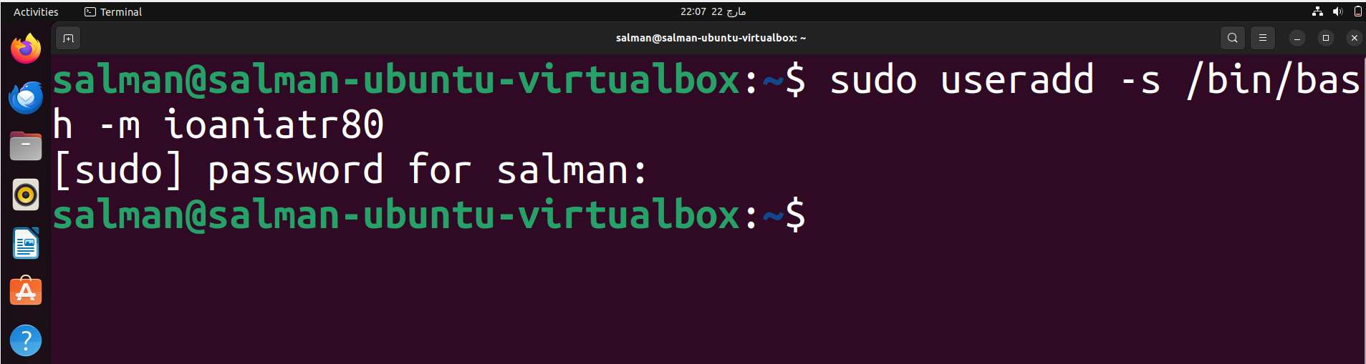

* + - * 1. To update an existing user, use the following command.

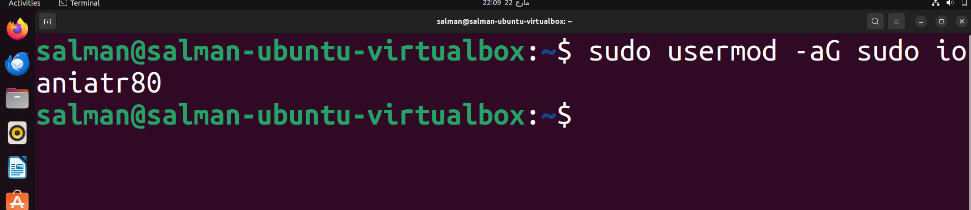

* + - * 1. To add a password on the user, use below described command.

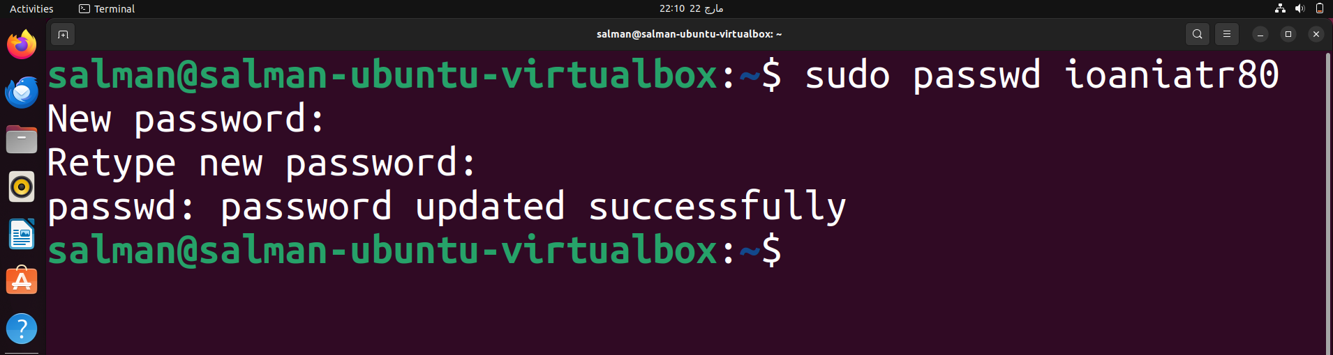

* + - * 1. To switch current or any user to root or super user,

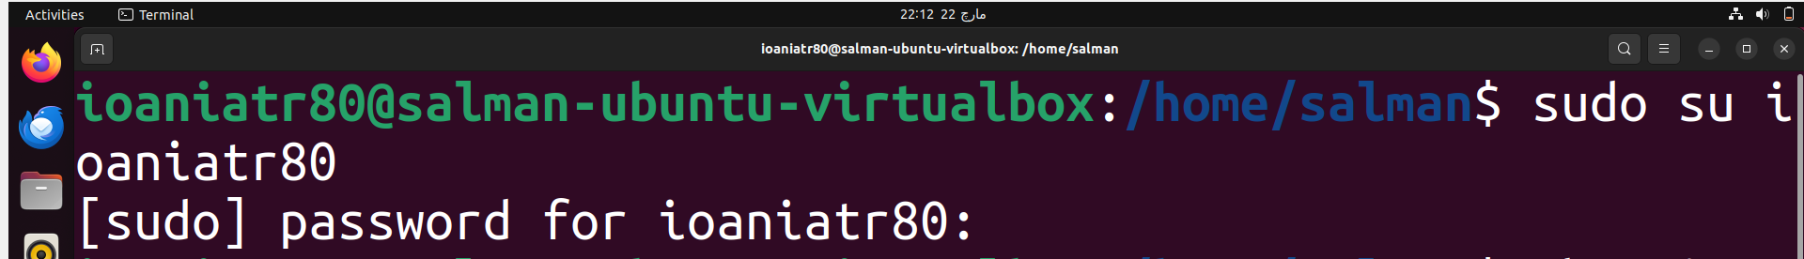

* + - * 1. To check which user is currently using the terminal session.

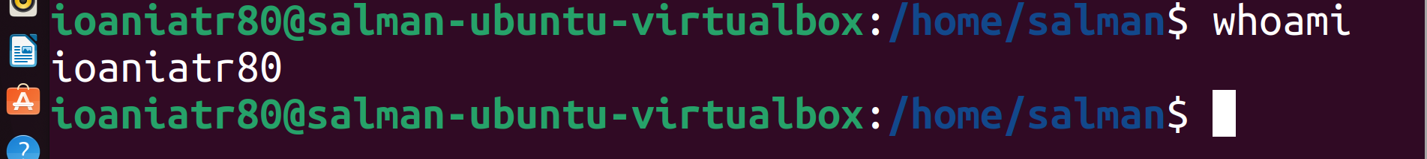

## These are some of the basic commands that Ubuntu provides us with.

* + 1. SSH Utility.
       1. This is called as secure shell. It is a networking software which can be used to make connection to remove servers and other computers as well as to transfer files between two computers or servers. It is called secure as it used new and advanced encryption to transfer files between different computers.
          1. In order to connect to a server or another computer on the network,

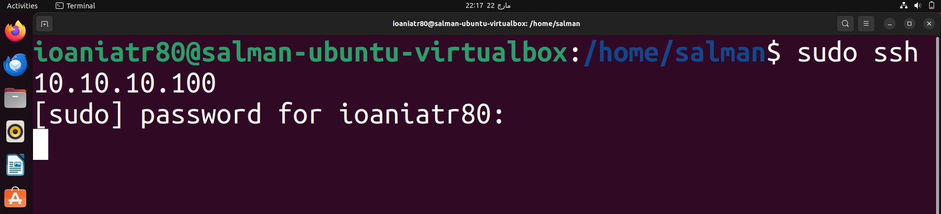

It will start looking for this IP Address on the network and if found it will make a connection with it.

### Ipconfig

* + - 1. This is also another networking tool and is used to check for IP Address of the system. It can also be used to check IP for different NIC’s if connected to the system. To check the IP of your current NIC or I should say as of your system,

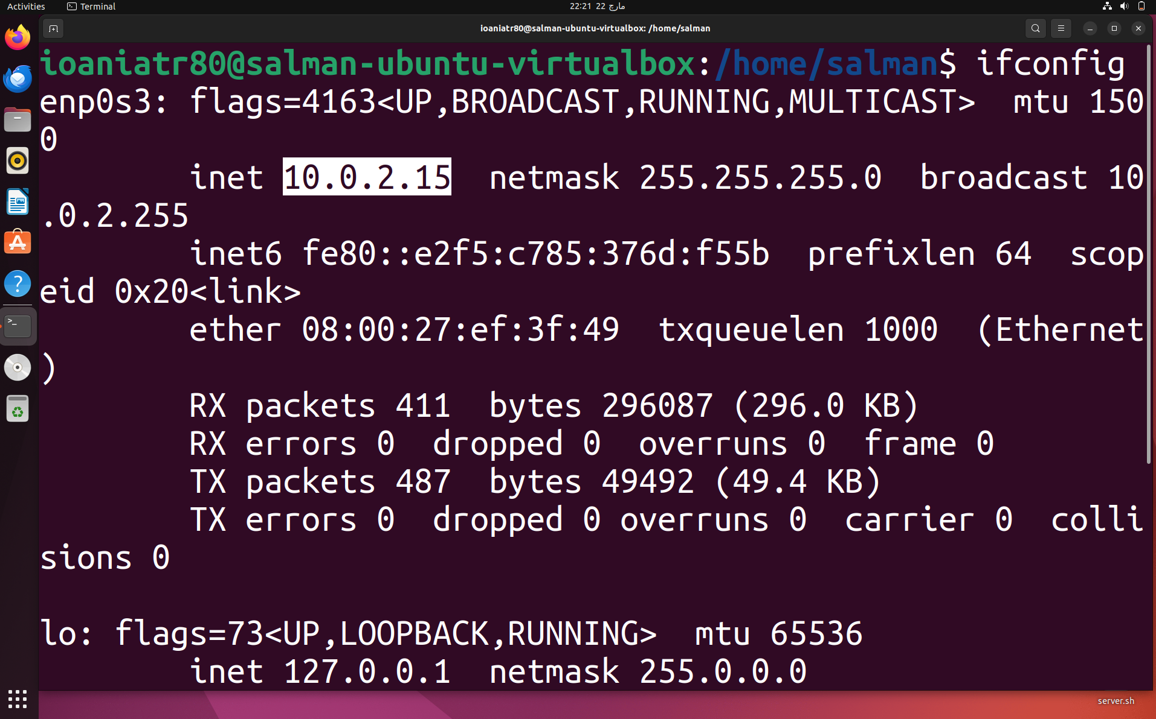

# 6.0. MS DOS Introduction.

## 6.1. Introduction.

### 6.1.1. MS Dos (Microsoft Disk Operating System) is an operating system that was first released in 1981 and was intended to run on systems such as Personal Computers. It served as a primary OS for computers till 1995 where it was replaced by the Windows 95 Operating System.

## 6.2. Kernel Usage.

### 6.2.1. As this OS is developed by Microsoft it supposed to use more Ram like new operating systems e.g. Windows 11. But in this case, it is not consuming a lot of resources as it is only running without any Graphical User Interface related to it. (GUI)

We can also change to different directories with the help of “dir” command as used by the Windows terminal.

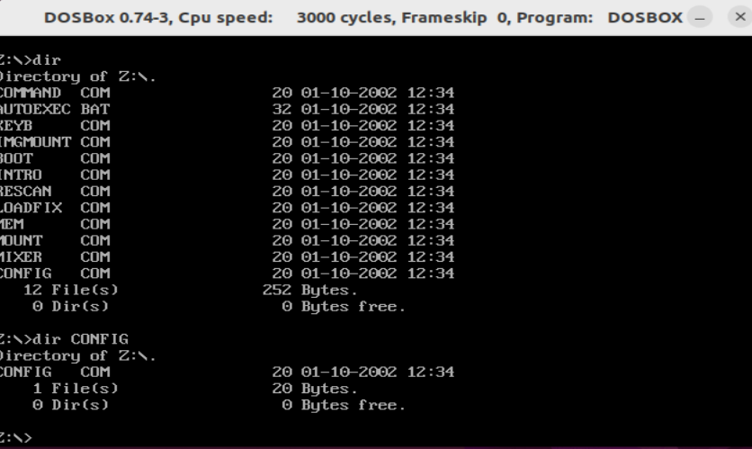

It is using almost same resources as Ubuntu as it doesn’t have any Desktop Interface associated with it.

## Basic Commands.

### This uses commands same as Windows terminal. To see directories of a folder use “dir” command. Similarly, “dir” command can also be used to change location from one folder to another.



In addition, to clear screen contents, we can use “cls” command it means clear screen. On the other hand, we use “clear” on an Ubuntu machine and “ls” to display directories on a Linux environment.

**Conclusion**.

Both Operating Systems are good and efficient in their own way. Ubuntu uses a Debian kernel and is managed till to date. On the other hand, MS DOS is now depreciated and don’t have any support from Microsoft. It is replaced by modern Operating Systems for simple users such as Windows 11, Windows 10. Moreover, Ubuntu OS requires a user with some technical knowledge to be able to operate it while MS-DOS or I should say as modern Windows OS doesn’t required any good technical skills to be able to operate and perform daily routine tasks.

Both OS(s) are good according to their own usage. Ubuntu doesn’t use much resources and is able to scale at a large industry. MS-DOS or Windows (modern) uses a lot of RAM (random access memory) and is more scalable for users who don’t have any good computer knowledge.

***THE END.***